LAB 2 :

Q1)The finance department of a company wants to calculate the monthly pay of their employees. Monthly pay should be calculated as below:

Monthly_pay = No.of hours worked in a week * rate per hour * No. of weeks in a month

include <stdio.h>

int main() {

    float hours_per_week, rate_per_hour, weeks_in_month, monthly_pay;

    printf("Enter the number of hours worked in a week: ");

    scanf("%f", &hours_per_week);

    printf("Enter the rate per hour: ");

    scanf("%f", &rate_per_hour);

    printf("Enter the number of weeks in a month: ");

    scanf("%f", &weeks_in_month);

    monthly_pay = hours_per_week * rate_per_hour * weeks_in_month;

    printf("The monthly pay is: %.2f\n", monthly_pay);

    return 0;

}

Q2) Rahul is planning a road trip from Delhi to Mumbai for his friend's wedding. He wants to know the distance between the two cities to estimate the fuel cost and journey time. Can you write a C program to help Rahul calculate the distance between Delhi and Mumbai?

#include <stdio.h>

int main() {

    float distance = 1450.0;

    float fuel_efficiency, fuel_price, fuel_cost, speed, journey_time;

    printf("Enter the fuel efficiency of your vehicle (in km/l): ");

    scanf("%f", &fuel_efficiency);

    printf("Enter the fuel price (per liter): ");

    scanf("%f", &fuel_price);

    printf("Enter the average speed during the trip (in km/h): ");

    scanf("%f", &speed);

    fuel_cost = (distance / fuel_efficiency) * fuel_price;

    journey_time = distance / speed;

    printf("The estimated fuel cost for the trip is: %.2f\n", fuel_cost);

    printf("The estimated journey time is: %.2f hours\n", journey_time);

    return 0;

}

Q3) Write a C program to covert Fahrenheit to Celsius

celsius = (fahrenheit - 32) * 5 / 9

#include <stdio.h>

int main() {

    float fahrenheit, celsius;

    printf("Enter the temperature in Fahrenheit: ");

    scanf("%f", &fahrenheit);

    celsius = (fahrenheit - 32) * 5 / 9;

    printf("The temperature in Celsius is: %.2f\n", celsius);

    return 0;

}

Q4)Write a C program to convert a given integer (in seconds) to hours, minutes and seconds

#include <stdio.h>

int main() {

    int total_seconds, hours, minutes, seconds;

    printf("Enter the number of seconds: ");

    scanf("%d", &total_seconds);

    hours = total_seconds / 3600;

    minutes = (total_seconds % 3600) / 60;

    seconds = total_seconds % 60;

    printf("Time: %d hours, %d minutes, %d seconds\n", hours, minutes, seconds);

    return 0;

}

Q5) Write a C program to calculate the speed when the distance travelled and time taken are provided by the user

#include <stdio.h>

int main() {

    float distance, time, speed;

    printf("Enter the distance traveled (in kilometers): ");

    scanf("%f", &distance);

    printf("Enter the time taken (in hours): ");

    scanf("%f", &time);

    speed = distance / time;

    printf("The speed is: %f km/h\n", speed);

    return 0;

}

LAB 3:

Q1) Check whether the number is positive or negative.

#include <stdio.h>

int main() {

    int num;

    // Ask the user for input

    printf("Enter a number: ");

    scanf("%d", &num);

    // Check if the number is positive or negative

    if (num >= 0) {

        printf("The number is positive.\n");

    } else {

        printf("The number is negative.\n");

    }

    return 0;

}

Q2) Check whether the number is positive or negative or zero.

#include <stdio.h>

int main() {

    int num;

    printf("Enter a number: ");

    scanf("%d", &num);

    if (num > 0) {

        printf("The number %d is positive.", num);

    }else if (num < 0) {

        printf("The number %d is negative.", num);

    }else {

        printf("The number %d is zero.", num);

    }

    return 0;

}

Q3) . Check whether the number is odd or even.

#include <stdio.h>

int main() {

    int num;

    // Ask the user for input

    printf("Enter a number: ");

    scanf("%d", &num);

    // Check if the number is even or odd

    if (num % 2 == 0) {

        printf("The number %d is even.\n", num);

    } else {

        printf("The number %d is odd.\n", num);

    }

    return 0;

}

Q4) Check whether a person is eligible for voting or not

#include <stdio.h>

int main() {

    int age;

    // Ask the user to enter their age

    printf("Enter your age: ");

    scanf("%d", &age);

    // Check if the person is eligible to vote (age 18 or above)

    if (age >= 18) {

        printf("You are eligible to vote.\n");

    } else {

        printf("You are not eligible to vote.\n");

    }

    return 0;

}

Q5) Largest among three numbers

#include <stdio.h>

int main() {

    int num1, num2, num3;

    // Ask the user to input three numbers

    printf("Enter three numbers: ");

    scanf("%d %d %d", &num1, &num2, &num3);

    // Check which number is the largest

    if (num1 >= num2 && num1 >= num3) {

        printf("The largest number is %d.\n", num1);

    } else if (num2 >= num1 && num2 >= num3) {

        printf("The largest number is %d.\n", num2);

    } else {

        printf("The largest number is %d.\n", num3);

    }

    return 0;

}

Q6) Read average marks and find the grade based on the following conditions: Avg marks > 80 => A grade Avg marks > 60 and <= 80 => B grade Avg marks > 40 and <= 60 => C grade Avg marks <= 40 => #include <stdio.h>

int main() {

    float avgMarks;

    // Ask the user to input the average marks

    printf("Enter your average marks: ");

    scanf("%f", &avgMarks);

    // Determine the grade based on the average marks

    if (avgMarks > 80) {

        printf("Grade: A\n");

    } else if (avgMarks > 60 && avgMarks <= 80) {

        printf("Grade: B\n");

    } else if (avgMarks > 40 && avgMarks <= 60) {

        printf("Grade: C\n");

    } else {

        printf("Grade: F\n");

    }

    return 0;

}

F grade

Q7) If a user enters a vowel, number, or any other character, the user gets fixed points in a game. 5 points for vowel, 10 points for number, and 0 for any other character. Display the points scored based on the character.

#include <stdio.h>

#include <ctype.h>

int main() {

    char input;

    int points = 0;

    // Ask the user to input a character

    printf("Enter a character: ");

    scanf("%c", &input);

    // Check if it's a vowel or number and assign points

    if (strchr("aeiouAEIOU", input))

        points = 5;   // Vowel

    else if (isdigit(input))

        points = 10;  // Number

    // Display the points scored

    printf("Points scored: %d\n", points);

    return 0;

}

Q8) User may type uppercase or lowercase letter as input. Based on lower or upper case, print the corresponding message

#include <stdio.h>

#include <ctype.h>

int main() {

    char input;

    printf("Enter a letter: ");

    scanf("%c", &input);

    if (islower(input)) {

        printf("You entered a lowercase letter.\n");

    }

    else if (isupper(input)) {

        printf("You entered an uppercase letter.\n");

    }

    else {

        printf("The input is not a valid letter.\n");

    }

    return 0;

}

Q9) A game is devised for learning the nature of roots of a quadratic equation based on the coefficients entered. Based on the coefficients, compute discriminant (b2 - 4ac) and check if the equation has real, imaginary, or equal roots. If it is equal roots, no points are rewarded. If real roots, 20 points are awarded, and if it is imaginary, 10 points are awarded. Compute the points for a user.

#include <stdio.h>

int main() {

    float a, b, c, discriminant;

    int points = 0;

    printf("Enter a, b, c: ");

    scanf("%f %f %f", &a, &b, &c);

    discriminant = b * b - 4 * a * c;

    if (discriminant > 0)

        points = 20;

    else if (discriminant < 0)

        points = 10;

    printf("Points: %d", points);

    return 0;

}

Q10) 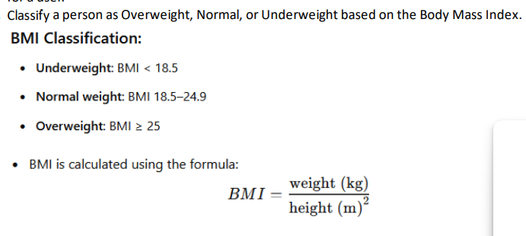

#include <stdio.h>

int main() {

    float weight, height, bmi;

    printf("Enter weight (in kg): ");

    scanf("%f", &weight);

    printf("Enter height (in cm): ");

    scanf("%f", &height);

    bmi = weight / (height * height);

    printf("Your BMI is: %.2f\n", bmi);

    if (bmi < 18.5)

        printf("You are Underweight.\n");

    else if (bmi >= 18.5 && bmi <= 24.9)

        printf("You have Normal weight.\n");

    else

        printf("You are Overweight.\n");

    return 0;

}

Q11) . Given x-coordinates and y-coordinates, find the quadrant in which the point lies

#include <stdio.h>

int main() {

    float x, y;

    printf("Enter x-coordinate: ");

    scanf("%f", &x);

    printf("Enter y-coordinate: ");

    scanf("%f", &y);

    if (x > 0 && y > 0)

        printf("The point (%.2f, %.2f) lies in the First Quadrant.\n", x, y);

    else if (x < 0 && y > 0)

        printf("The point (%.2f, %.2f) lies in the Second Quadrant.\n", x, y);

    else if (x < 0 && y < 0)

        printf("The point (%.2f, %.2f) lies in the Third Quadrant.\n", x, y);

    else if (x > 0 && y < 0)

        printf("The point (%.2f, %.2f) lies in the Fourth Quadrant.\n", x, y);

    else if (x == 0 && y != 0)

        printf("The point (%.2f, %.2f) lies on the Y-axis.\n", x, y);

    else if (y == 0 && x != 0)

        printf("The point (%.2f, %.2f) lies on the X-axis.\n", x, y);

    else

        printf("The point (%.2f, %.2f) is at the Origin.\n", x, y);

    return 0;

}

Q12) Check whether the entered year is leap year or not

#include <stdio.h>

int main() {

    int year;

    printf("Enter a year: ");

    scanf("%d", &year);

    if (year % 400 == 0) {

        printf("%d is a leap year.", year);

    }else {

        printf("%d is not a leap year.", year);

    }

    return 0;

}

Q13) 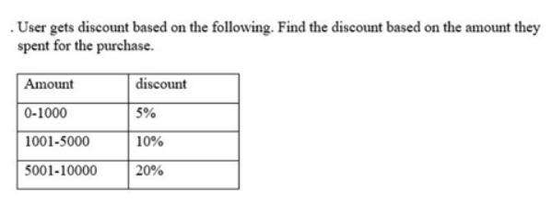

#include <stdio.h>

int main() {

    float amount, discount, final_amount;

    printf("Enter the purchase amount: ");

    scanf("%f", &amount);

    if (amount >= 0 && amount <= 1000) {

        discount = 0.05 * amount;

    }

    else if (amount > 1000 && amount <= 5000) {

        discount = 0.10 * amount;

    }

    else if (amount > 5000 && amount <= 10000) {

        discount = 0.20 * amount;

    }

    else {

        discount = 0;

        printf("No discount available for this amount.\n");

    }

    final_amount = amount - discount;

    printf("Discount: %.2f\n", discount);

    printf("Final amount to be paid: %.2f\n", final_amount);

    return 0;

}